**[Skip to content](https://vfw5985.net/" \l "main)**

Top of Form

Bottom of Form

**[](https://vfw5985.net/)**

[**VFW Post 5985**](https://vfw5985.net/)

Pacific Beach, San Diego, California

* [**Home**](https://vfw5985.net/)
* [**Calendar & Food Menu**](https://vfw5985.net/calendar/)
* [**Links**](https://vfw5985.net/links/)
* [**Meetings**](https://vfw5985.net/meetings/)
* [**Membership**](https://vfw5985.net/membership-application/)
* [**Officers & Committees**](https://vfw5985.net/officers/)
* [**Programs**](https://vfw5985.net/programs/)
* [**CHAPLAINS CORNER**](https://vfw5985.net/event-types/)

**VFW Pacific Beach Post 5985**

We are located in the northern part of Pacific Beach, a few blocks from the beach. We do not offer food on a regular basis, but members and their guests can bring in food for consumption on the premises. (Restaurants are within walking distance.) At no time shall you bring your own alcohol for consumption on the premises, per the Alcohol Beverage Commission.

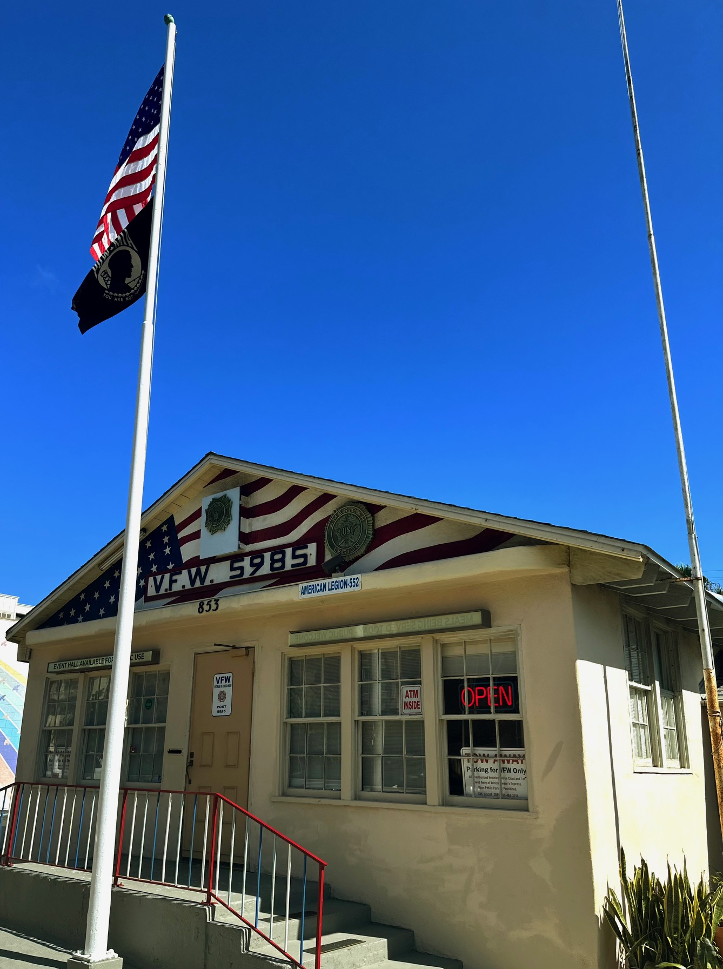

Our facility houses the VFW Post 5985, American Legion Post 552 and its Auxiliary, and Sons of the American Legion Squadron 552. Four VFW Posts merged with Post 5985 in the 1970s: Bert Allen Post 2415, Ramon Moreno Post 1780, and Clairemont Post 4089. In March 2009, Mission Bay Post 11044 merged with us. Accordingly, our geographical areas cover Pacific Beach, Mission Beach, Mission Bay, Clairemont, Bay Park, and Bay Ho. The Pacific Beach Woman’s Club meets in the facility, as do some other civic organizations.

We welcome personnel from all the uniformed branches of the U.S. Armed Forces, whether active duty, retired, veterans, National Guard, or Reserve. The location where and when you may have served does not matter, nor does the uniformed service. It too does not matter that you belong to another veteran’s organization or are a family member or guest of an authorized person. Approximately 95% of the population is eligible to join one or more of the organizations present within the facility. In sum, we want you to join us!

Per the rules of the Alcohol Beverage Commission, you must be a member to be served alcohol, unless you are part of a recognized function within our establishment. As a guest of a member, you cannot directly purchase the alcohol. Your sponsor must do so.

A member is classified as an individual who is an active member of any veteran’s organization or its auxiliary and current in dues; a membership card is required. If active duty, per the laws of California, you are an authorized patron for serving an alcoholic beverage.

Dues for any of our resident organizations can be paid via your online account or at the Post via the bartender. The yearly dues for the VFW are $45.00, American Legion $50.00, and SAL Squadron 552 $36.00. For the VFW, you are strongly urged to join as a Life Member, as that rate, based on age, is extremely generous.

**VFW Membership**

Last updated on February 15, 2025:

|  |  |
| --- | --- |
| Members in Good Standing | 294 |
| New members | 21 |
| Life Members | 224 |
| Expiring Members | 30 |
| Total Membership Paid Up | 267 |
| Prior Year | 276 |
| **Percentage** | **97.1%** |

**Canteen Hours**

|  |  |
| --- | --- |
| Monday through Sunday | 2:00 pm to 9:00 pm |
| When breakfast is served | TBD |

[**VFW5985_Large_Font_Bar_Rules_2024**Download](https://vfw5985.net/wp-content/uploads/2025/03/VFW5985_Large_Font_Bar_Rules_2024.pdf)

**Meeting Schedule**

|  |  |
| --- | --- |
| VFW Post Membership VFW House Committee | 2nd Thursday each month at 6:00 pm House Committee meets at 5:00 pm |
| Facility Committee | Tuesday prior to VFW Post meeting each month at 6:00 pm |
| American Legion Post 552 | 3rd Thursday each month at 6:00 pm |
| SAL Squadron 552 | 4th Thursday each month at 6:00 pm |
| American Legion Auxiliary 552 | 3rd Tuesday each month at 6:00 pm |

**EVENTS AND FOOD**

Please see the [**Calendar page**](https://vfw5985.net/calendar/) to find out what's happening this month at VFW Post 5985.

**VFW Post 5985  
853 Turquoise Street  
Pacific Beach  
San Diego, California 92109**

**(858) 488-3631**

[**Email the Post Commander**](mailto:vfw5985@gmail.com)

Copyright © 2025 - VFW Post 5985